The formation period should be between two to five years for the Contrarian model, and between three and twelve months for the Momentum model. I have chosen six, nine, twelve, twenty-four, thirty-six, and forty-eight months as time horizons, and the test results are listed below.

I selected the monthly CRSP return data during 1965-1989 and used SQL to check how many different companies are there in the data set and to determine the number of groups. Each year, there are approximately 2000-3000 companies included, and to fit the number of securities in each group between 30 and 50, I ranked the companies into 60 groups. Group 0 is the loser group and Group 59 is the winning group. The number of securities in past winners and losers varies between 25 and 48.

The strategy selects the stocks based on the past J months' average returns and holds them for K months (Jegadeesh and Titman, 1993). Portfolios with overlapping holding periods are examined, and in each month t, the strategy buys the winner portfolio and sells the loser portfolio. First, I calculated the cumulative return using the moving product and rank the sample into 60 groups to find past winners and past losers every month. I also set the testing period up to 36 months after formation. Second, I calculated the average return for each formation date and ranked the portfolio each month after the formation date based on cumulative returns. The winner group and the loser group are sorted out, and I calculated the difference between the winner and the lower. Third, I did the regression for winner and loser to calculate their mean and t value, and I transposed the result into readable form. The above procedures were repeated many times with different formation periods, and I collected the results into a single form. Finally, I plotted the cumulative return overtime for the difference between winner and loser.

**PanelA**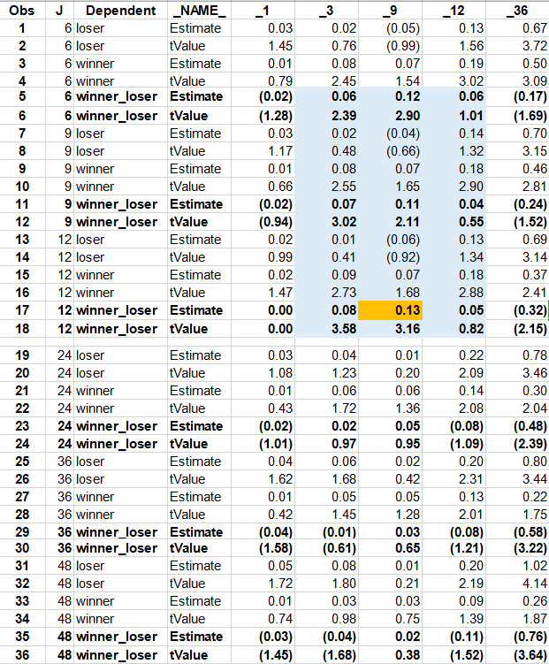

We can see from the table that the most successful strategy selects stocks based on their last 12 months performance and holds the stocks for 9 months, generating a return of 13% per month. The relative strength strategy with a formation period between 3-12 months is generally very profitable. The contrarian strategy achieves a positive average return of over 5% except for month 1 and 36. In this sample, the return is highest when the holding period equals 9 months. And the returns increase as the time horizon gets longer within one year. The return starts to decrease in the 24th month and reach its bottom at the end of the fourth year in my table. Besides, t-statistics generally decreases as the holding period becomes longer within one year formation period. The t-statistic for the highest return is 3.16, indicating that its estimate is significantly different from zero, and has a 1% significance with a degree of freedom around 50. We can find a corresponding z value of 2.576 for the highest return. The portfolio with a 12 month formation period and 12 month test period are not statistically significant (t-statistics of 0.82). Most t-statistics for portfolios formed over 2-5 years fell below 1.65, indicating that there is less than 10% significance, thus we cannot rule out the possibility that the reversal is not possible.

**Panel B**

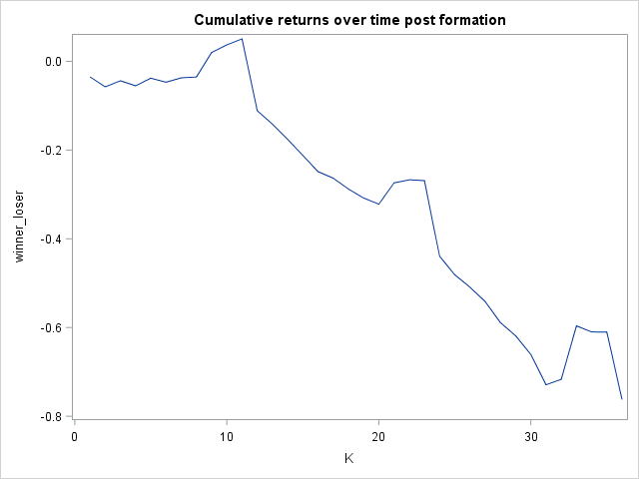

The graph shows that the cumulative return of the past winner exceeds the cumulative return of the past loser in the first September and October, and then keeps decreasing. By the end of the 36 months, the past loser has accumulated more returns than the past winner and the decrease is more significant every January. A possible explanation for the January effect is that some firms tend to delay the realization of net income to pay fewer taxes at the end of the year and realize the income at the beginning of the next fiscal year. That also explains why the average returns over the formation period for companies in the loser group are lower than other companies. The price reversal can be easily observed from the graph and the effect amplifies as time gets longer. The graph conforms to Jegadeesh and Titman’s finding in 1993 that the predictable price changes based on past cumulative returns may not be permanent, but differ slightly in the statement that the negative abnormal return starts around twelve months after the formation date. In my sample, past loser returns exceed that of past winners even in the first eight months. In this case, the return persistence as the evidence of under reaction is minimized, and the reversal is asymmetric.

From my perspective, market overreaction is related both to the psychological part of individual decision making, and to the market behavior (De Bondt and Thaler, 1985). More specifically, the differences come from the investors from outside of the company when they react to publicly available information, for example, when a company's annual report is released; and the difference may come from inside the company, typically when managers want to make the financial position of a company looks good and they manage earnings. The results may vary as people changes, and there may be different pattern then there is new policies released.

References:

De Bondt, Werner F. M. and Richard Thaler, 1985, Does the stock market overreact? Journal of Finance 40, 793-805. •

Jegadeesh, N. and S. Titman, 1993, Returns to Buying Winners and Selling Losers: Implications for Stock Market Efficiency, Journal of Finance 48, 65-91.